**Manual Test Evidence**

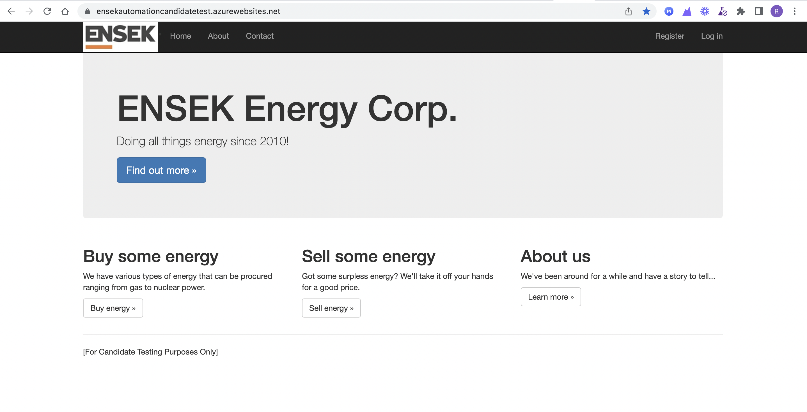

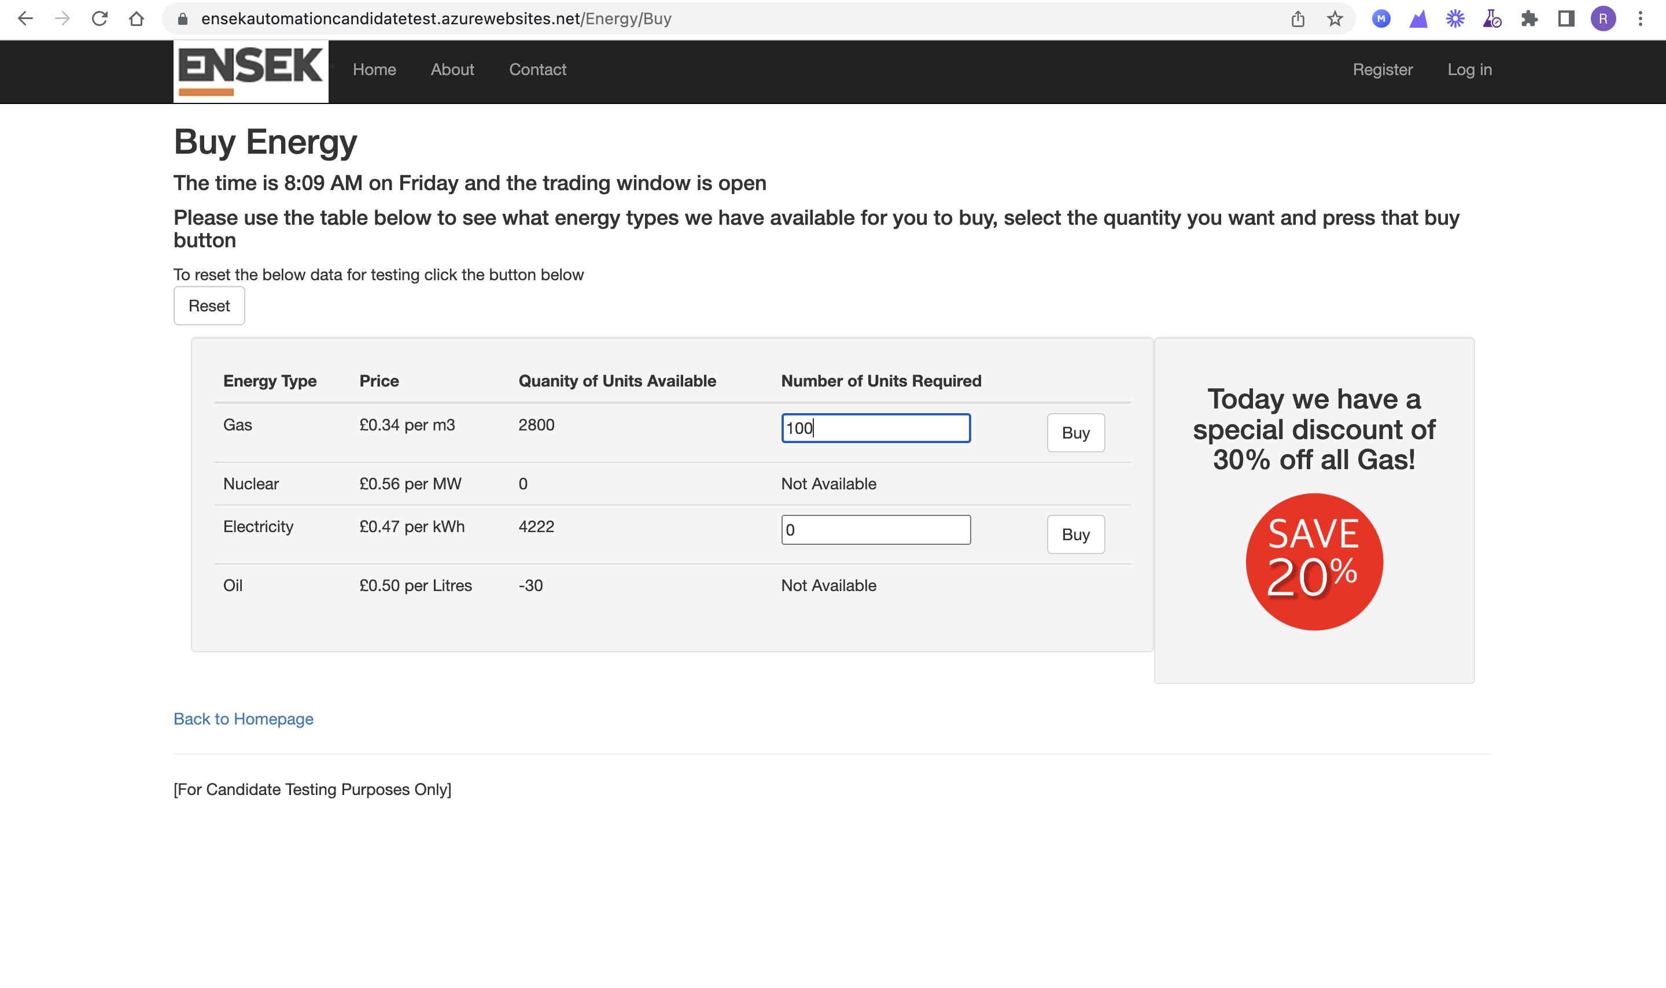

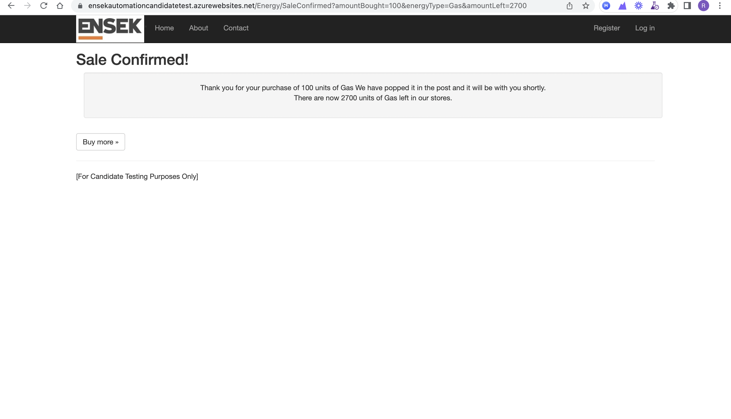

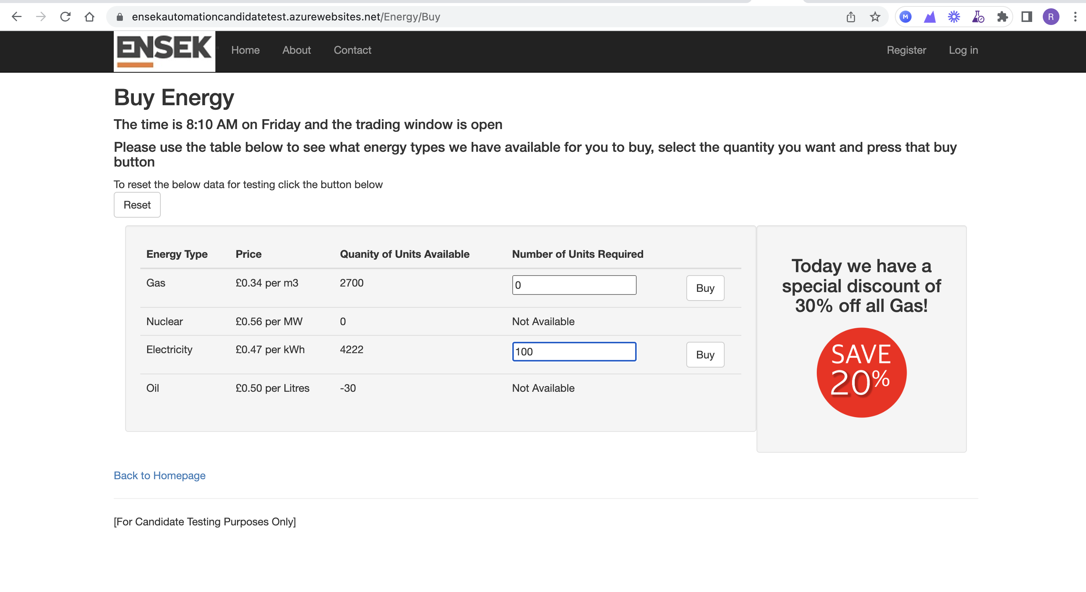

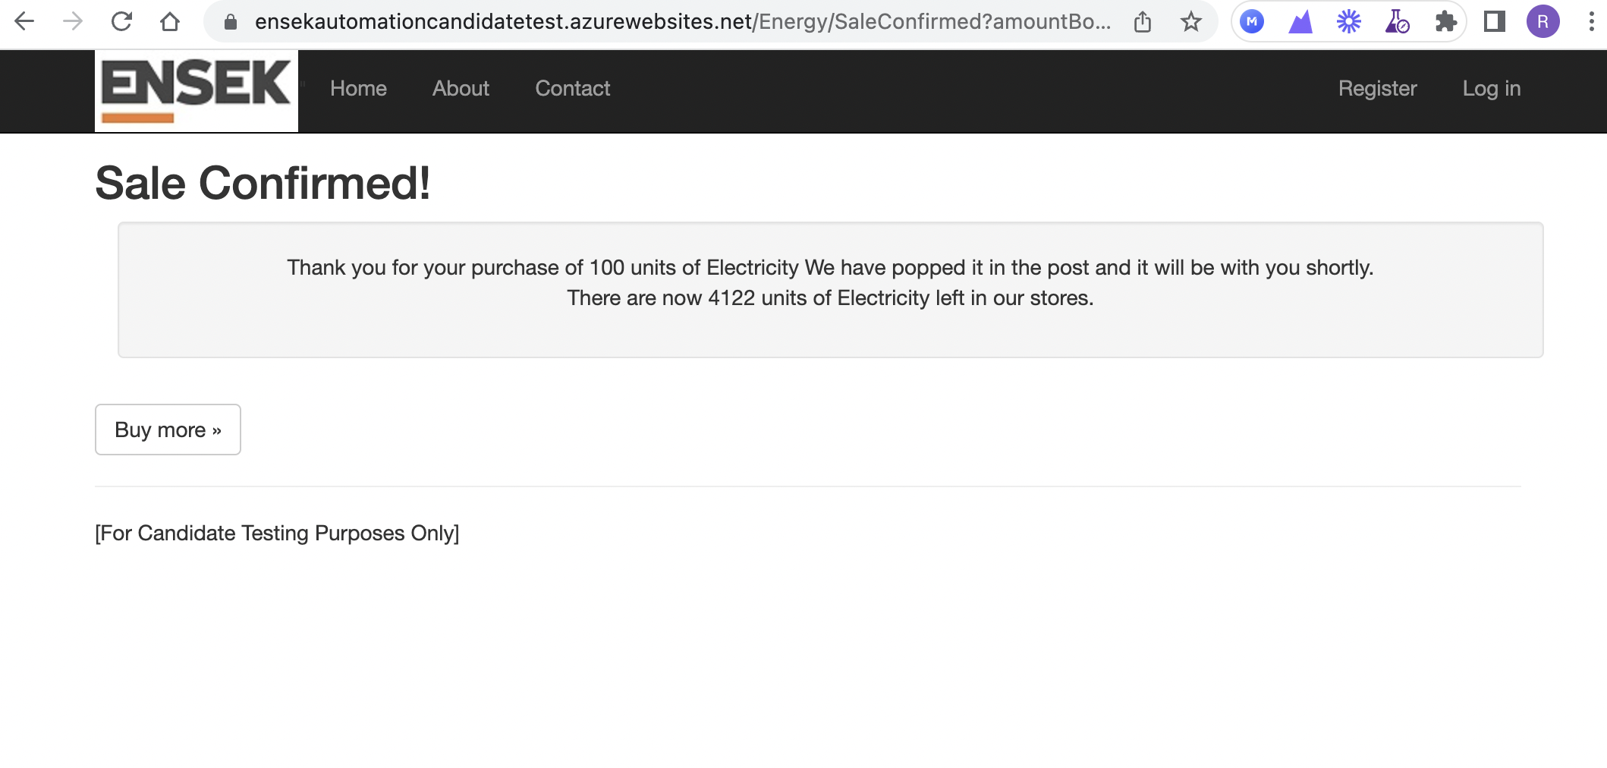

**Automation:** For the website you have provided <https://ensekautomationcandidatetest.azurewebsites.net/> I have used TestIM as Selemium I need to install Java jar files, install many things like Eclipse etc.

However, if its Selenium I follow right from scratch by creating framework and use POM model and the below is what I will follow based on my experience.

Firstly, I create 4 packages namely PageObjects, Functional Tests, Properties and

Testsuite.

In this model first I would create a class named "PageBase" where I will keep all commonly

used methods. I would create a class with “Individual Page Objects” where I call all

the functionalities that are to be tested. In respective to Individual page objects, I will

also create functional tests where I will perform actions in that.

I will locate the elements in the webpage by using location strategies like Xpath, Id, Name, etc using Firefox add-ons like Firebug, Fire path and Fire finder.

Here I will use OPPS Concepts like Inheritance, Encapsulation etc. “PageBase” is Inherited by “Individual Page Objects” and “Functional Tests”.

Functional Tests are instantiated by “Individual Page Objects”. Here I will also create two more files like “OR” Object repository where I will keep all the Xpaths for future usage(when ui change occur) and Properties file where I will declare url, operating systems, browsers etc.

I will Create a Test suite where I can keep the functional tests in it. To run all

functional tests just I will run the test suite. Although functionalities are added day by

day just I will add that class name in Test suite and I will perform regression testing. I will

use Junit framework for running these automation Test scripts. I will create a build

file to run the project using ANT. I will go to command prompt and compile and run the build file to get the reports.

**Automation Test Evidence from TestIM Tool**

I have used TestIM tool to automate scripts and the JAVA language is built in it.

This is how it captured the elements and I need to add the Test Data.

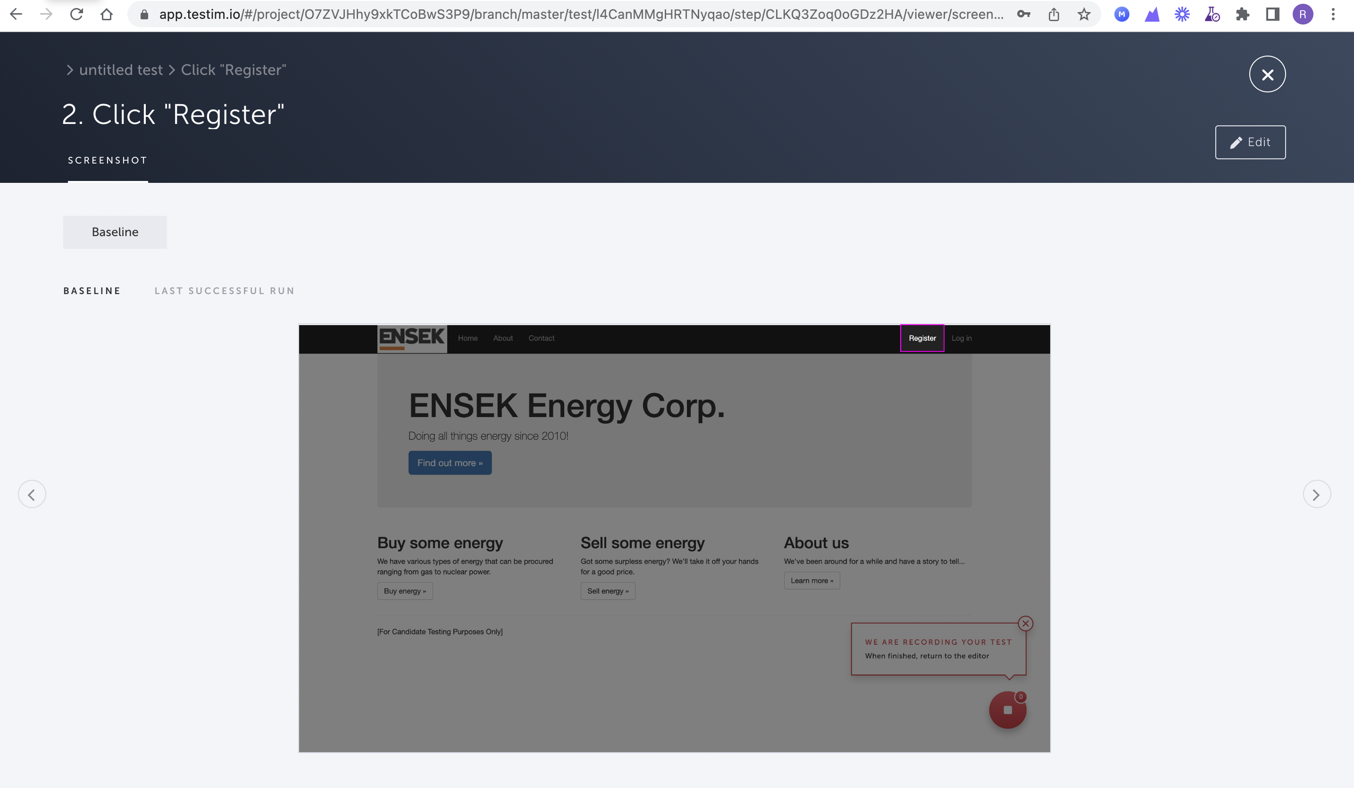

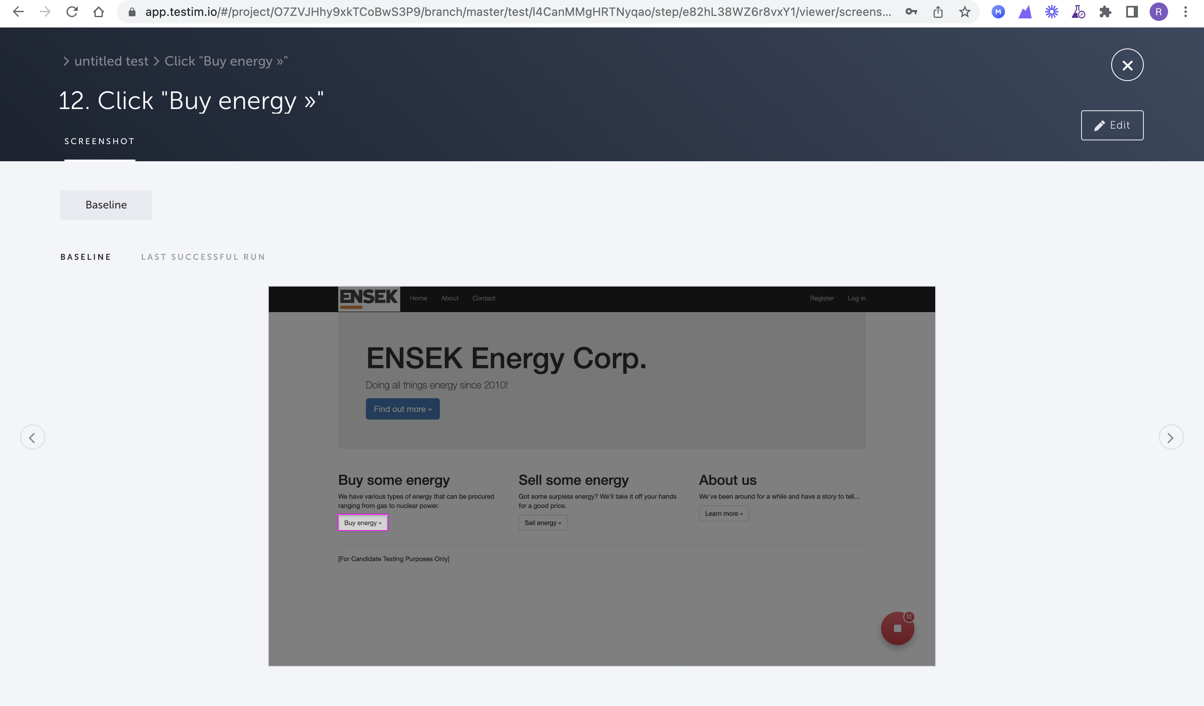

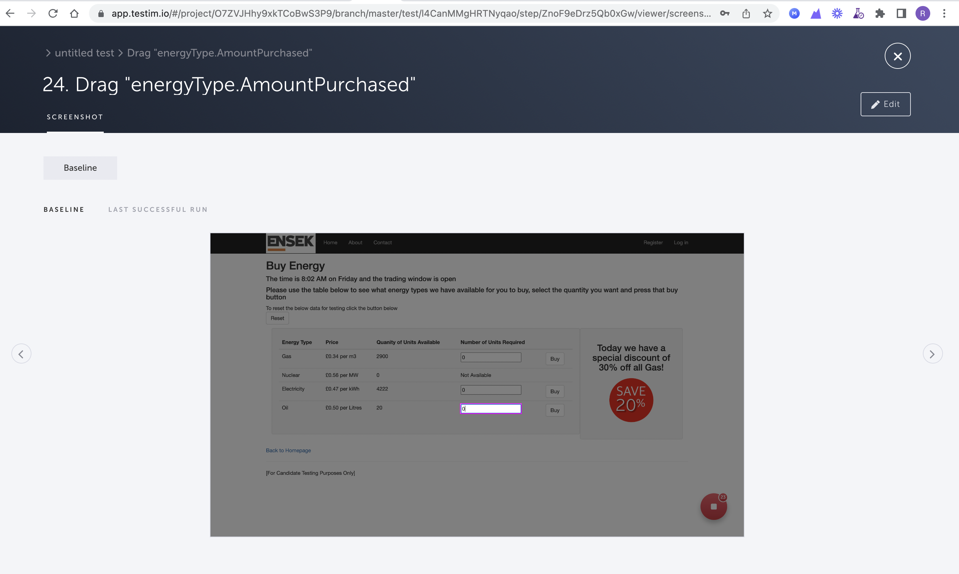

Every Element will be highlighted

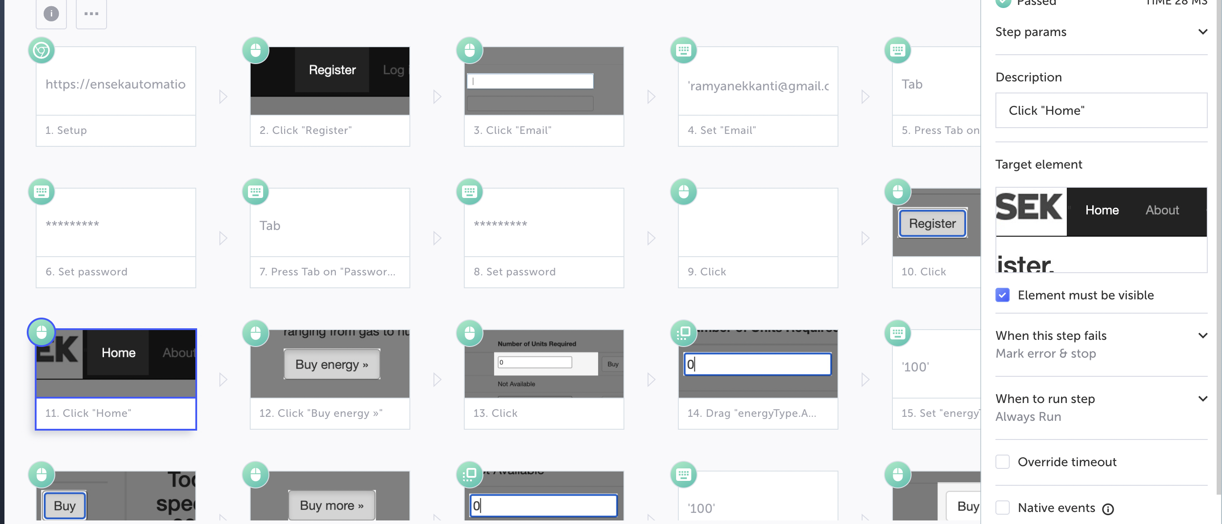

**API Testing**

For API Testing we need to understand the parameters and correct format of the data to input

**PUT -** This call creates a new entity and updates the existing entity.

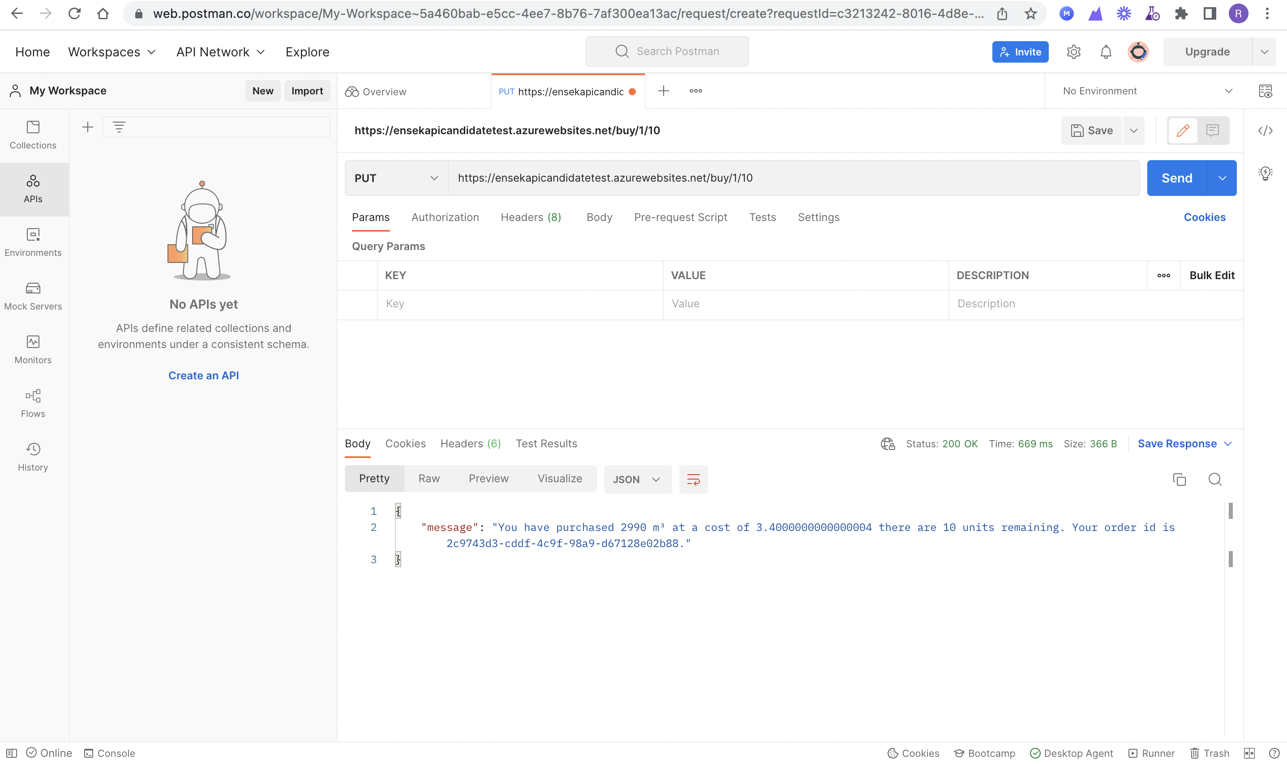

**GET -** This call sends the request and receives the response.

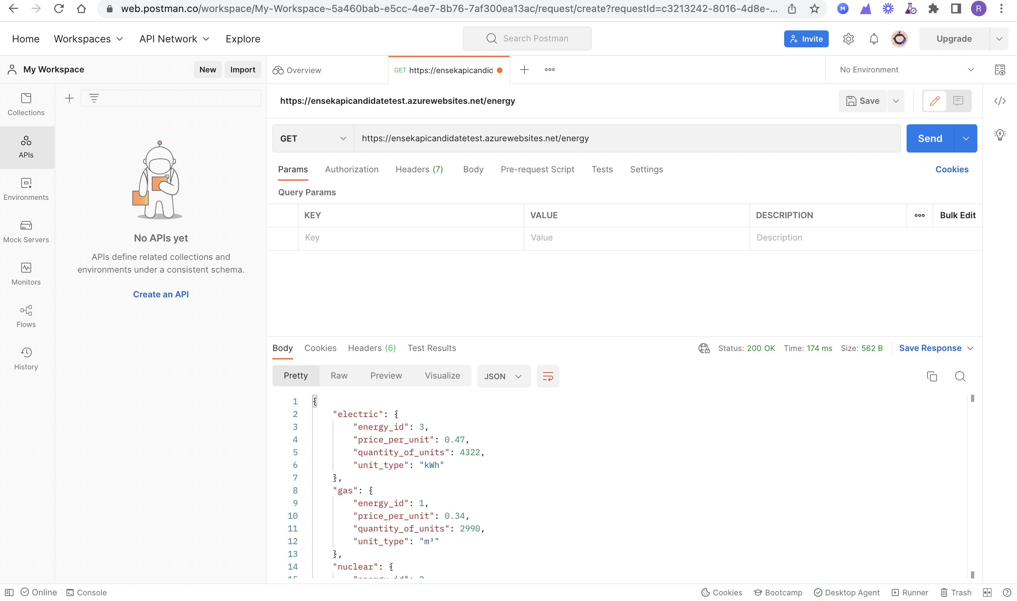

Get – Orders - This call sends the request and receives the response.

